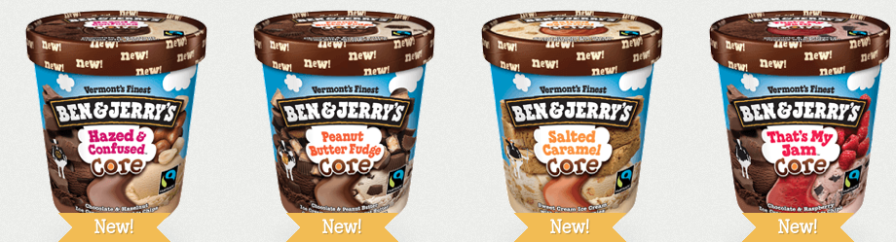Macintosh HD:Users:dkwashlaw:Desktop:Screen Shot 2014-03-04 at 10.48.01 PM.pngMacintosh HD:Users:dkwashlaw:Desktop:Screen Shot 2014-03-04 at 10.53.41 PM.pngMacintosh HD:Users:dkwashlaw:Desktop:Screen Shot 2014-03-04 at 10.50.45 PM.pngMacintosh HD:Users:dkwashlaw:Desktop:Screen Shot 2014-03-04 at 10.45.25 PM.png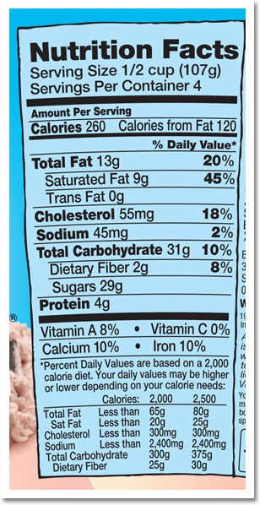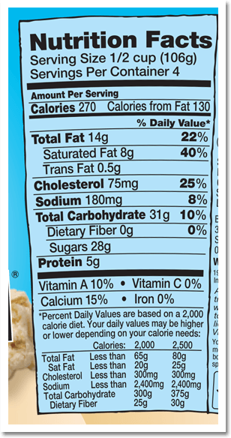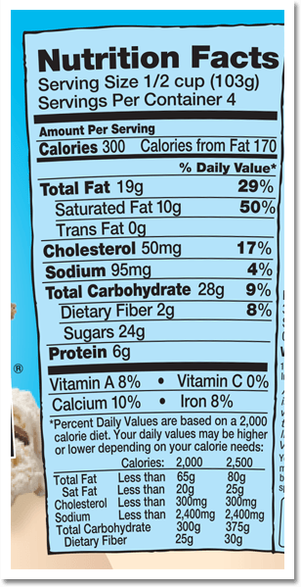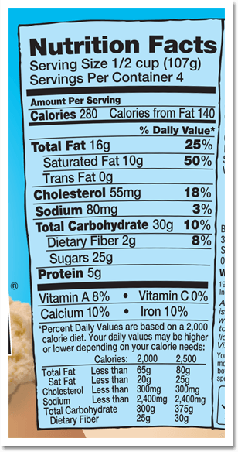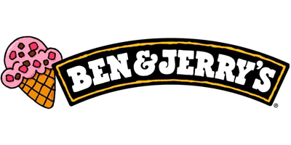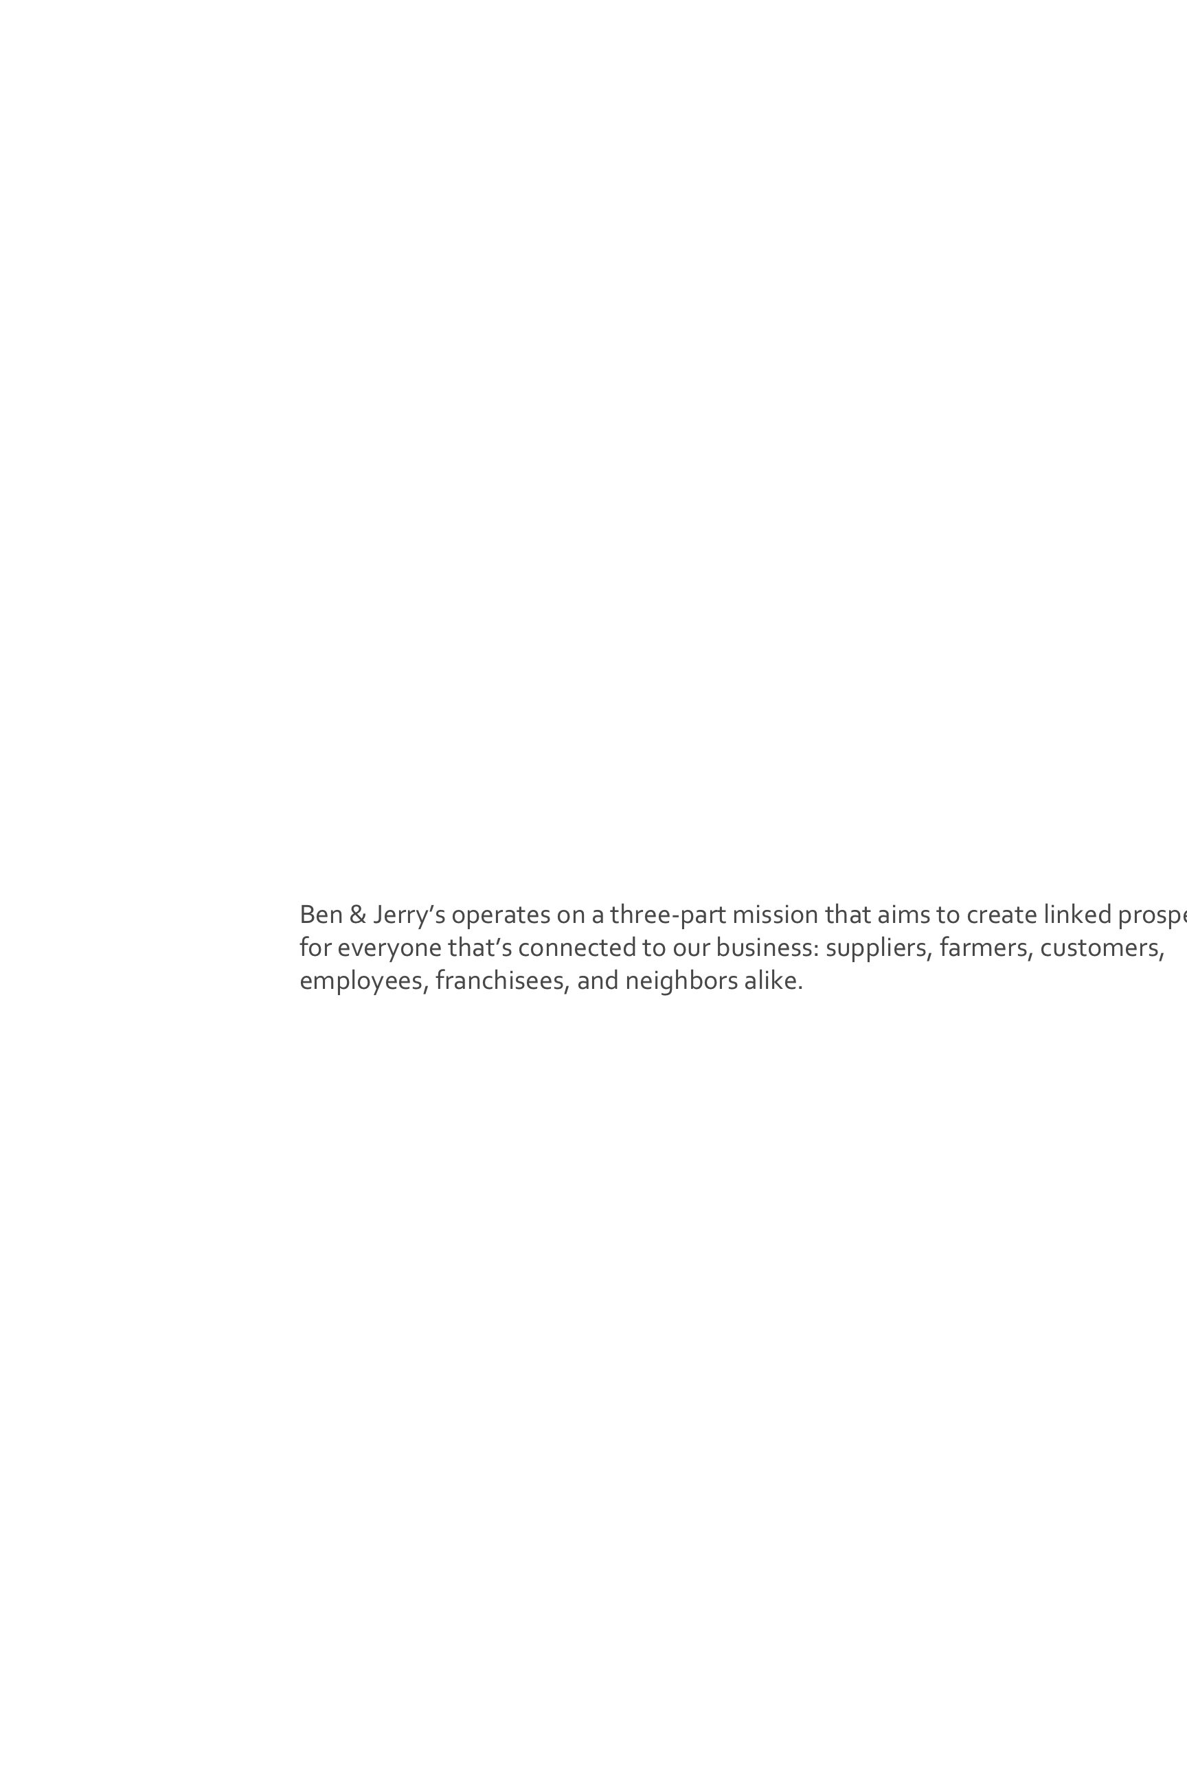

The Ben & Jerry’s Core flavors can be found at supermarkets, convenience stores, and grocery stores around the country for $4.39/pint. They will be made available in scoop shops in Spring 2014.

## Production Process

Each pint starts with a cow – tens of thousands of them. At the Co-op, the milk is separated into heavy cream and condensed skim milk, then shipped by tanker truck to the St.Albans and Waterbury Vermont factories. At the factory, the milk and cream are pumped into four 6,000=gallon storage silos, and kept cool at 36 degrees until conversion time. The Mix Master then combines heavy cream, condense skim milk, liquid cane sugar, egg yolks, cocoa powder and for chocolate flavors, and natural stabilizers. All of the ingredients are blenderized in the Blend Tank, a 1000-gallon stainless steel mega-blender, for 6 to 8 minutes. The ice cream is then both pasteurized and homogenized. After the mix has “simmered”, it is pumped from the Tank Room to the Flavor Vats where ice cream is euphorically flavored and an incredible range of flavorings, purees, and extracts and even a few liqueurs are added. Ice cream is then frozen and turned through the Fruit Feeder for chunky flavors. Chunkless flavors, like Vanilla or Chocolate, are pumped directly to the pint-filling machinery. Finally, the final swirl is added, the ice cream is packaged and frozen, then prepared to be delivered to a store near you – after the Quality Assurance Lab gives the thumbs up, of course.

## Availability & Pricing

Ben & Jerry’s Homemade, Inc. introduces the future of ice cream with its new Cores, the first full line of Ben & Jerry’s to be 100& Fairtrade certified and made with Non-GMO sourced ingredients. The “Core” line is modeled after their popular Karamel Sutra Flavor. Each flavor includes a core center of fudge, caramel or real raspberry jam to perfectly complement the two premium ice cream flavors and multitude of chunks packed into every pint providing a spooning experience like never before.

## About

## Nutrition Information

# F A C T S H E E T

### **PHONE**

**(802)-846-3500**

### **Web**

[**www.benjerry.com**](http://www.benjerry.com)

### **Ben & Jerry’s Homemade Inc.**

**30 Community Drive  
South Burlington, VT, 05403-6828**

## March 2014